% Q4 driver
close all
clear all
clc
t = [1.3 1.7 1.9 2.3 2.7 3.1 3.6 4.0];
y = [2.8 3.2 3.1 3.5 4.8 4.2 5.3 4.8];
spline_plot(t,y)
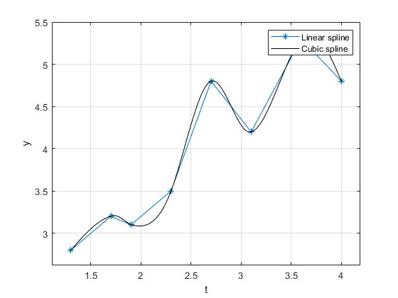
Published with MATLAB® R2021a

